Exploratory Data Analysis (EDA) Report

Data Analytics Internship Assignment

1. Introduction
EDA is the process of exploring and understanding a data set through various statistical tools to discover hidden patterns and trends from the data set. This report provides an exploratory analysis of the sales data set using Microsoft Excel. The analysis covers data cleaning, descriptive statistics, Pivot Table analysis, graphs, trend analysis, and outlier identification.

2. Dataset Overview
The dataset contains sales transaction records including information such as:
- Order ID
- Order Date
- Product Name
- Quantity
- Unit Price
- Total Price
- Payment Method
- Order Status
These variables were used to understand customer purchasing behaviour, product performance, sales trends, and payment preferences.

3. Data Cleaning
The dataset was first cleaned before carrying out the analysis.
The below processes were done:
- Check for any missing values.
- Confirm that there were no duplicates.
- Check that all dates were properly formatted.
- Ensure that the numeric columns such as Quantity, Unit Price, and Total Price had numeric data.
- Confirm that all categorical values such as Product, Payment Method, and Order Status were the same.
The dataset became ready for analysis after cleaning.

4. Descriptive Statistics
The following descriptive statistics were calculated using Microsoft Excel.
Statistic | Value
Total Orders | [Total Orders]
Total Revenue | [Total Revenue]
Average Sales | [Average Sales]
Median Sales | [Median Sales]
Minimum Sale | [Minimum Sale]
Maximum Sale | [Maximum Sale]
These statistics provide an overall understanding of the sales performance and distribution of transaction values.

5. Product Sales Analysis
- Pivot Table was used to examine the amount of sales made by each product.
- The findings indicated that certain products had managed to make significantly more sales than others due to their popularity among customers. The products that made most sales accounted for a large percentage of total sales, whereas some other products managed to make relatively low sales.
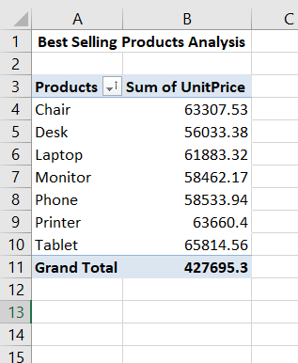
- Such data can be useful for the company’s inventory and marketing decisions and below is the analysis evidence.

6. Payment Method Analysis
- A pivot table has been constructed to determine the mode of payments preferred by customers.
- It is evident from the analysis that the frequency of each payment mode chosen by customers is as follows: The mode of payment most frequently chosen by customers was [Most Used Payment Mode].
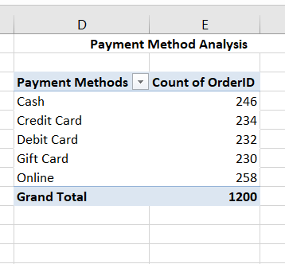
- This knowledge would help organizations facilitate payment convenience.

7. Order Status Analysis
- Order Status Analysis was done using Pivot Table.
- The greater number of orders were delivered successfully whereas a lesser number was canceled or returned.
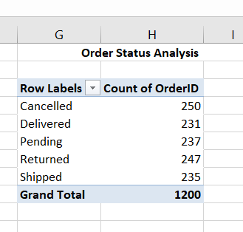
- It shows that order fulfillment process by the company is quite efficient but the orders which were canceled or returned need to be analyzed.

8. Monthly Sales Trend Analysis
- Monthly Sales Analysis involved the creation of a pivot table from extracting the month from the order date and summarizing the total price.
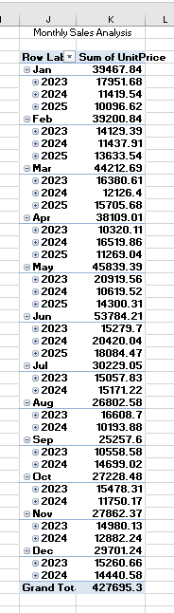
- There is evidence that there was fluctuation in the monthly sales pattern during the year. There have been months where sales were more than other months.

9. Outlier Analysis
- The total price column was subjected to the box and whiskers test for outliers.
- There were some transactions that were recorded as outliers because of their high value. They could be bulk purchasing or high-quality goods. However, they are legitimate transactions; thus, they were kept in the data set.

10. Data Visualisations
The following visualisations were created using Microsoft Excel:
- Bar Chart – Product Sales

- Pie Chart – Payment Method Distribution

- Line Chart – Monthly Sales Trend

- Box and Whisker Plot – Outlier Detection

11. Key Findings
The analysis revealed various important insights including:
- The firm made a total income of [Total Income].
- The average income per transaction is [Average Income].
- [Product Name] made the most sales income.
- [Payment Option Most Used] was the most popular payment option among customers.
- The majority of orders were delivered successfully.
- Monthly sales fluctuated over the course of the year, suggesting seasonal buying behavior.
- Few orders of high amounts were identified as outliers.

13. Conclusion
This data exploration exercise has managed to analyze the sales data through the use of Microsoft Excel. The various steps involved included data cleaning, computation of descriptive statistics, creation of Pivot Tables, charting and detection of outliers.
The results that have been obtained in this case are useful for making proper decisions in business.

